Deep Learning Lab Assignment-1

Name: Saketh Garuda
ID: 16

Introduction:

This lab assignment helps in learning about the working of tensor flow with logistic regression using python. Visualization charts and graphs are created and displayed in tensor board.

Objective:

The main objective for this lab assignment is to know the working of
- Logistic regression using tensor flow
- Creating visualization graphs using tensor board
- To change the hyper parameters and get the results

Configuration:

- PyCharm IDE
- Python 3.6.4
- TensorFlow

Approaches/Methods:

Applying the sigmoid function to the given equation in order to get the result in Boolean function,
- Z= Sigmoid(X*W+b)
To calculate the loss we have used the built in entropy function ‘tf.nn.sigmoid_cross_entropy_with_logits()’,
- loss = tf.reduce_mean(tf.nn.sigmoid_cross_entropy_with_logits(logits=Z, labels=y))

Workflow:

The workflow for the entire model is as follows,
- Importing load_breast_cancer from sklearn datasets
- Assigning data and target datasets to the define variable
- Reshaping the array of values to tensor flow values
- Minimizing error using cross entropy
- Gradient descent
- Initializing the session
- Creating the graphs usinf FileWriter method
- Displaying cost reduction for each iteration
- Calling the function
- Calculating accuracy score for the regression model

Dataset:

The dataset consists of 569 rows and 30 columns consist of 2 classes.

Parameters:

The parameters to be considered while constructing the model are,
- No over fitting of the model
- There should be no empty values in the set
- Must use gradient descent optimizer for accurate results

Evaluation and Discussion:

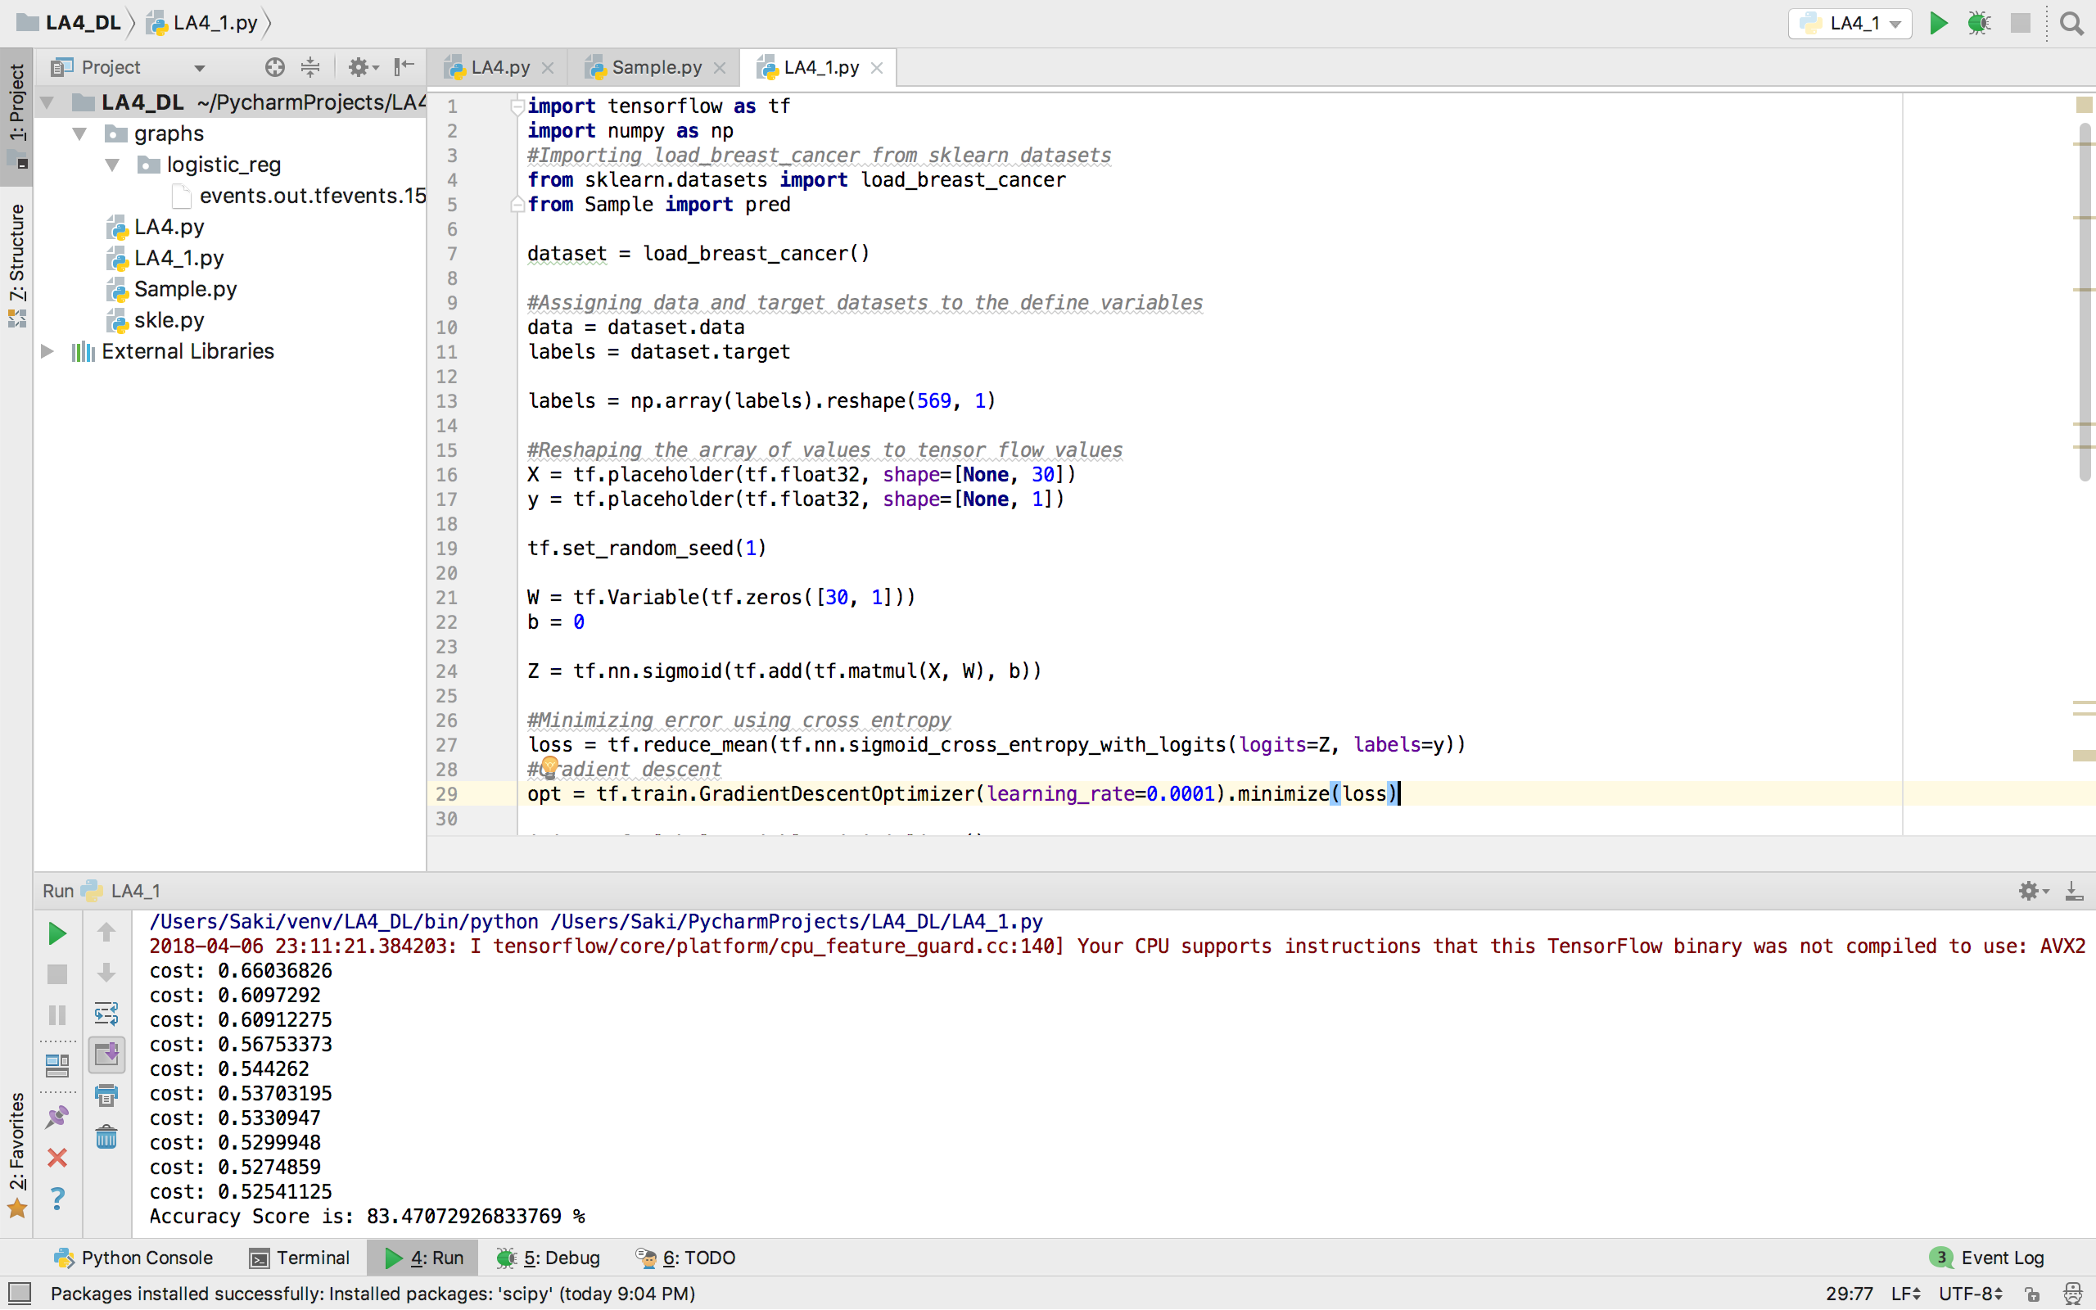

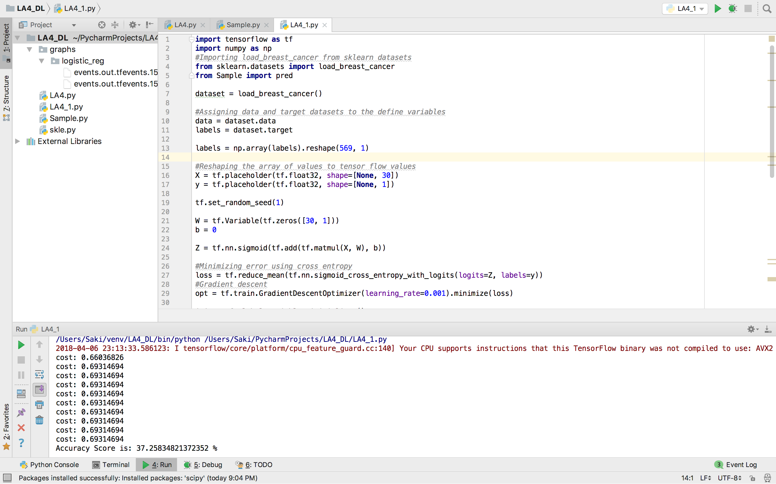

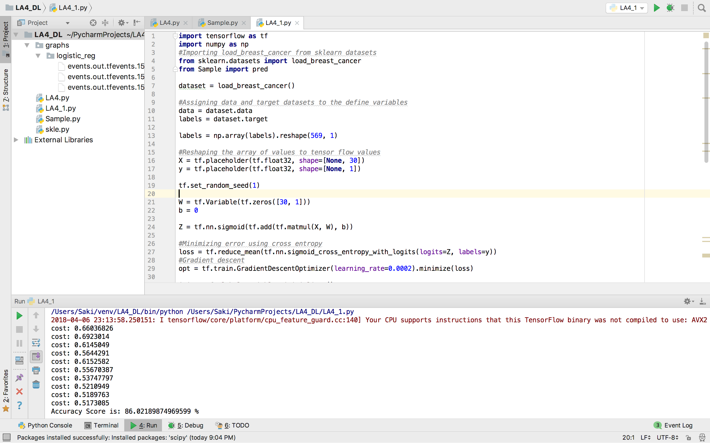

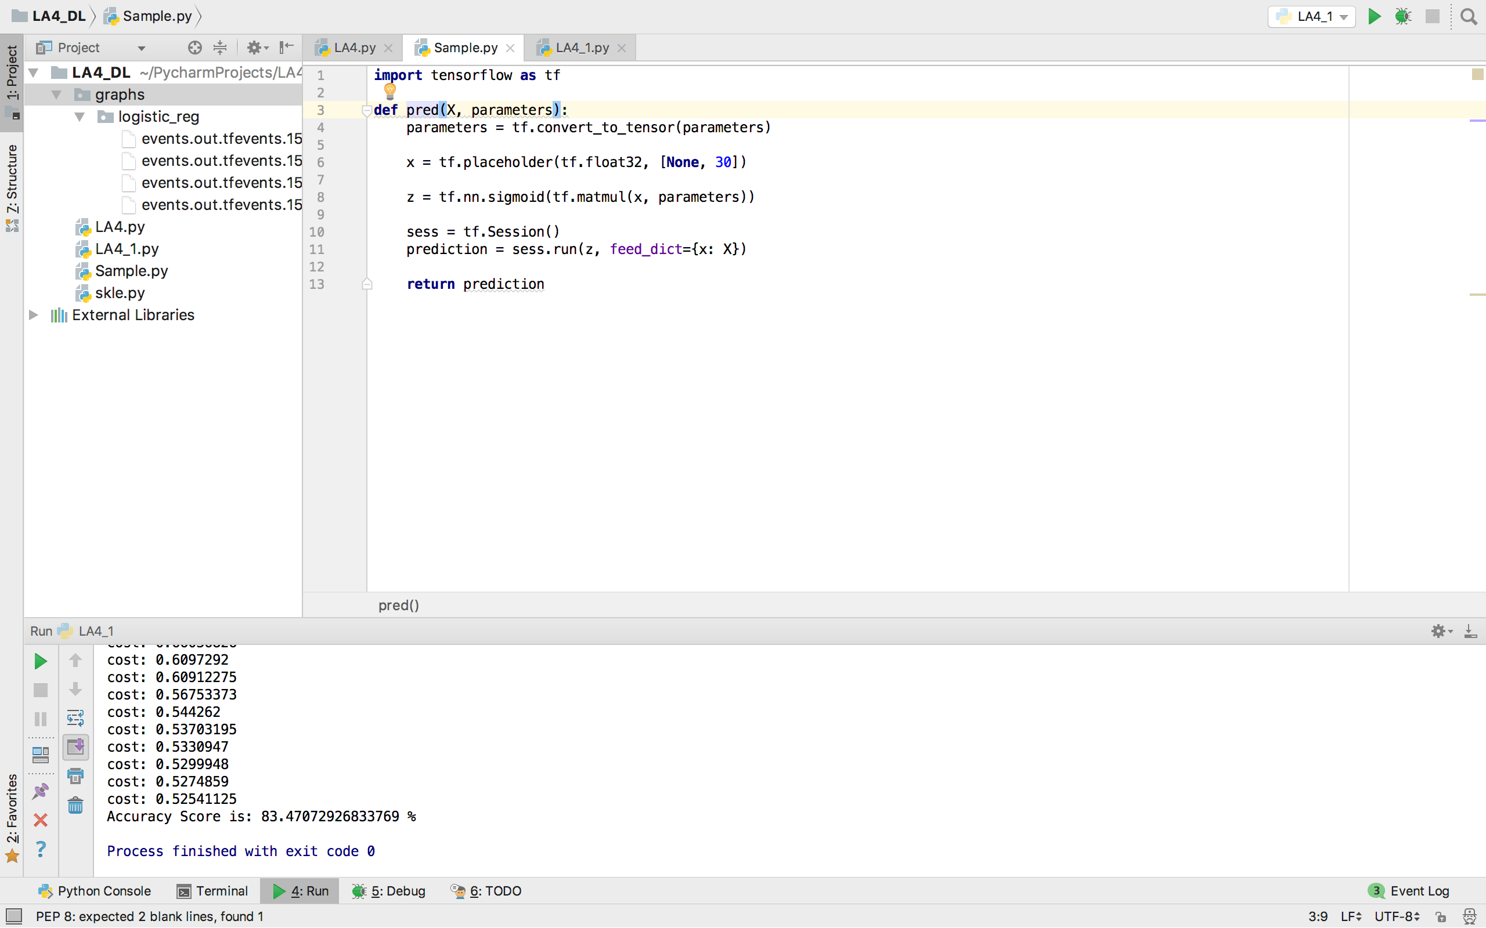

When we change the hyper parameter i.e. learning rate the accuracy rate varies for each iteration. If learning rate is increased the accuracy is decreased accordingly and if learning rate is decreased then the accuracy is increased.

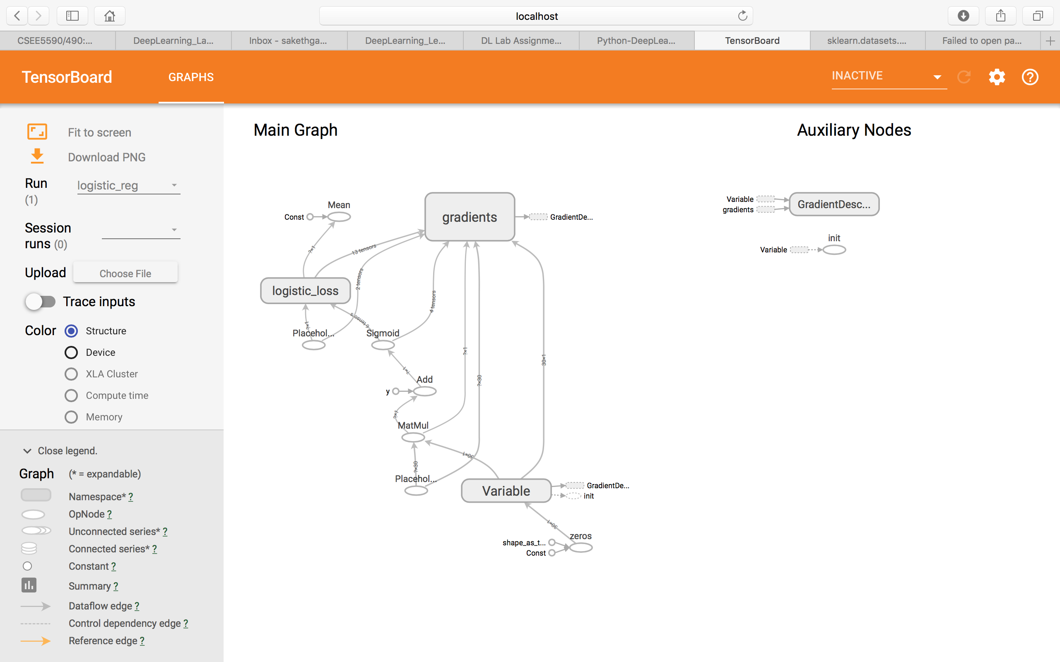

References:

- http://scikit-learn.org/stable/modules/generated/sklearn.datasets.load_breast_cancer.html
- https://www.tensorflow.org/tutorials/wide

